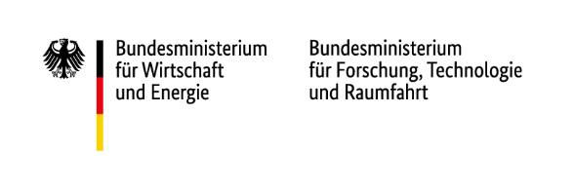

Horizon Europe Application Masterclass: Crafting a winning proposal in pillar II

National Contact Points Digital and Industrial Technologies (NKS-DIT), Climate, Energy, Mobility (NKS-KEM) and Bioeconomy and Environment (NKS-B&U)

13th of October 2026 | online

Programme

09:00 – 09:10 |  | Welcome & Introduction
09:10 – 09:50 |  | Presentation of the fictitious topic and the project idea
09:50 – 10:05 |  | Q&A on fictitious topic and the project idea
10:05 – 10:20 |  | Time to read the topic and project description + coffee break
10:20 – 10:30 |  | Distribution to break-out rooms and icebreaker in groups
10:30 – 11:30 |  | Session 1
11:30 – 11:40 |  | Coffee break
 | 11:40 – 12:40 | Session 2
 | 12:40 – 13:20 | Lunch break
 | 13:20 – 14:20 | Session 3
 | 14:20 – 14:45 | Presentation of results and Q&A

